|  |  |  |  |
| --- | --- | --- | --- |
| Artifact ID:  REQ-002 | Artifact Title:  Requirements Validation Email | |  |
| Revision:  1.2 | Revision Date:  2 OCT 2019 | |
| Prepared by:  Jesse Krage | | Checked by:  Garret Gang |
| Purpose:  Show the approval from IMSAR of requirement matrix v1.4 | | |

# Revision History

|  |  |  |  |  |
| --- | --- | --- | --- | --- |
| Revision | Revised by | Checked by | Date | Description |
| 1.0 | Garret Gang | Daniel Sharp | 19 SEPT 2019 | Initial Version |
| 1.1 | Garret Gang | Daniel Sharp | 30 SEPT 2019 | Specified version of matrix approved. |
| 1.2 | Jesse Krage | Garret Gang | 2 OCT 2019 | Additional info for Validation, added reference to NOTE-003 |

# Reference

|  |  |  |
| --- | --- | --- |
| Artifact ID | Revision | Title |
| NOTE-001 | 1.0 | Meeting Notes With IMSAR |
| NOTE-003 | 1.0 | Phone Meeting Notes |

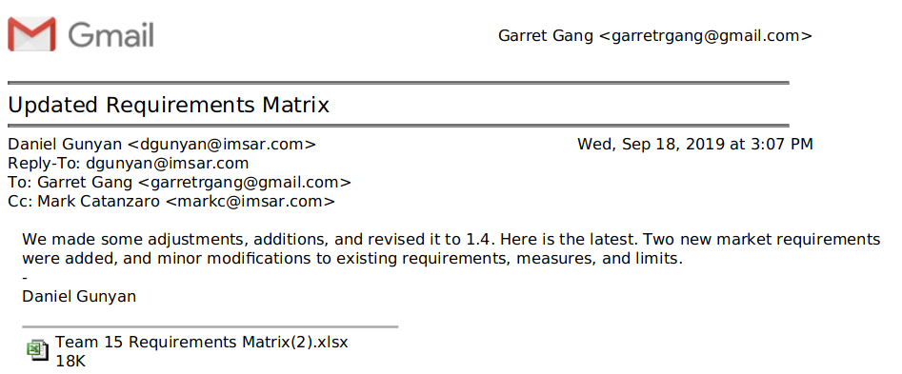

We conversed with Mark on who the market representatives are. He mentioned that the main userbase work at IMSAR. He communicates with the representatives who operate out of IMSAR’s facility. He has been checking our requirements and key success measures with those market representatives. During a phone call with the team, Mark used their feedback and his own personal experience to help us to define our key success measures and requirements (see NOTE-003).